Certificate of Analysis

General properties:
Name： HO-PEG5000-COOH
Molecular Weight： 5000 Dalton
Cat.#：R-1049
Lot.#：1509511
Manufacture Date： 2015.08.13
Date of Analysis： 2015.08.13
Recommended Retest date： 2016.08.13
Stability： 12 months
Storage： -20°C in the dark

Structure

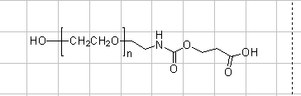

Items | Specification | Results
Appearance | White/ Off-white solid | White solid
¹H NMR | Identical to the Structure | Identical to the Structure
Foreign Material | None | None
Purity | ＞90% | 90%
Report Date: 2015.08.13

This product is for research use only, Not for human or animal use

